Barnsley College
Single Equality Scheme
2024-25

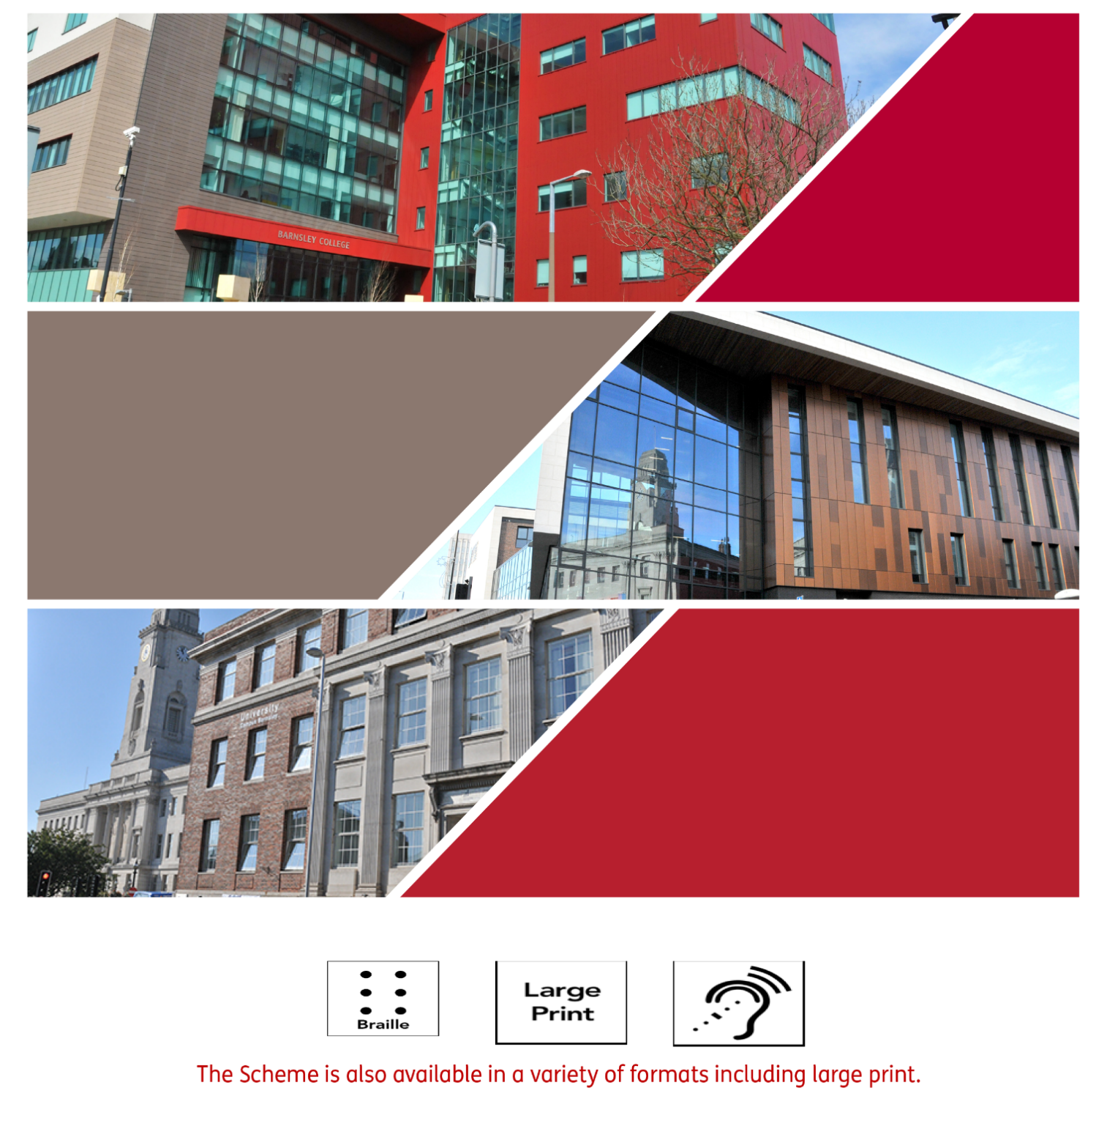

Contents
Introduction 3
Section 1 – Key Principles 4
Section 2 - Developing the Scheme 4
Section 3 - Meeting our Duties 4
Section 4 – Equality Act 2010 6
Section 5 - Equality and Eliminating Discrimination 6
Section 6 - Harassment and Bullying 6
Section 7 – Monitoring and Reporting Our Progress 6
Section 8 – Roles & Responsibilities 7
Section 9 - Good Practice in Staffing Issues 7
Section 10 – Training 7
Section 11 – Equality Impact Assessments 7
Section 12 - Publicity and Awareness of the Single Equality Scheme 8
Section 13 - Positive Action to Promote Choice, Opportunity and Progression 8
Section 14 – Complaints relating to Equalities 8
Section 15 - What happens if the Single Equality Scheme is not adhered to? 8
Appendix A – Vision, Purpose, Values and Drivers 10
Appendix B – Our Specific Equalities Commitments 11
Appendix C - Monitoring Our Progress 12
Appendix D - Roles & Responsibilities 14
Appendix E – Human Resources 16
Appendix F - Complaints 16
Appendix G – Legislation 17

Introduction

We believe that all those who form the community at Barnsley College or ITS (“the College”) (governors, staff, learners, visitors and contractors) have a right to be valued equally and to have equality of opportunity.

We will promote shared values that include equality and diversity, valuing and involving our community, showing care and respect for others and demonstrating honesty and fairness in everything, we do. The delivery and promotion of equal opportunities underpins the College’s Vision.

Barnsley College, as a public body, is subject to legislation to:
- eliminate discrimination, harassment and victimisation;
- advance equality of opportunity;
- foster good relations across the protected characteristics of:
  - age
  - disability
  - gender reassignment
  - race
  - religion or belief
  - sex
  - sexual orientation;
  - pregnancy and maternity;
  - marriage and civil partnership.
We aim to foster a culture where everyone in the College community can flourish and fulfil their potential.

Section 1 – Key Principles
The purpose of this Single Equality Scheme is:
- to create an inclusive environment underpinned by fair and equitable practices and procedures in which all members of the community can feel valued and respected;
- to provide a framework for good practice in all matters relating to members of the College community;
- to provide a framework for the provision of, and access to, the facilities, benefits and services that the College provides;
- to ensure that all members of the community are aware of their responsibilities under the Equality Act 2010;.
- to inform the development of the Single Equality Scheme Action Plan;
- to ensure adherence to relevant College procedures.

Section 2 - Developing the Scheme

In developing the original Single Equality Scheme, we consulted staff and students and have continued to develop and update the Scheme to reflect legislative changes and feedback from learners, staff and stakeholders. We regularly seek students’ views on our equality and diversity practices to ensure that we are focusing on issues and developments that are relevant and of benefit to students, mainly through the Learner Voice mechanism.

Section 3 - Meeting our Duties

The Equality Act sets out specific duties for public sector organisations as follows:

(a) eliminate discrimination, harassment, victimisation and any other conduct that is prohibited by or under this Act;
(b) advance equality of opportunity between persons who share a relevant protected characteristic and persons who do not share it;
(c) foster good relations between persons who share a relevant protected characteristic and persons who do not share it.

In order to meet our legal duties, we will endeavour to ensure that:
- staff, students, contractors, suppliers and stakeholders are aware of the value placed upon equal opportunity and the Single Equality Scheme and that action will be taken in the event of any breach of the Scheme;
- Governors and staff have access to relevant and appropriate information which assists them to plan, implement and monitor actions to carry out their responsibilities under the Scheme;
- the College’s publicity materials present appropriate and positive messages about protected groups, is clear and easily understood;
- our admissions criteria do not include unduly restrictive conditions or requirements;
- schemes of work, lesson content and teaching resources demonstrate sensitivity and positive promotion of protected groups;
- all learners can access appropriate support and facilities;
- applicants for employment are drawn from a wide pool with positive action to encourage applications from under-represented groups;
- recruitment and promotion procedures are designed and implemented to eliminate unlawful discrimination;
- we create a working environment underpinned by fair and equitable practices and procedures in which all members of the community can feel comfortable;
- we actively tackle discrimination on the basis of a protected characteristic whether overt, covert or by omission;
- all partners, contractors and consultants are committed to equality and diversity in service provision;
- staff development schemes are designed to meet the particular needs and enhance the skills of individuals of all under-represented groups;
- we gather and use information on how the College’s policies and practices affect the educational opportunities available to, and on the achievements of, protected groups;
- we assess the impact of our policies on staff and students from protected groups.

Section 4 – Equality Act 2010
The Act came into operation on 1st October 2010, with further public sector duties, known as the equality duty, coming into force in April 2011. The College Single Equality Scheme and Action Plan were amended to reflect changes that affect the College staff, students and others in the College community.

The Equality Act and its public sector duties cover all nine protected characteristics:
- Age
- Disability
- Gender reassignment
- Marriage and civil partnership
- Race
- Religion or belief
- Sex
- Sexual orientation
- Pregnancy and maternity
The public sector equality duty requires public bodies to:
- eliminate discrimination, harassment and victimisation;
- advance equality of opportunity;
- foster good relations.

Section 5 - Equality and Eliminating Discrimination
At Barnsley College, we are committed to embedding good practice across all of the protected characteristics. We will aim to eliminate unlawful discrimination and break down institutional barriers before they can affect people. We will aim to remove any barriers that we have not foreseen swiftly and sensitively as soon as they become apparent.

See Appendix B for full details of the College’s specific commitments in relation to the protected characteristics.

Appendix G provides information relating to legislation across all equality strands.

Section 6 - Harassment and Bullying
We aim to foster an environment in which all members of the College community can work and study effectively. Harassment and bullying are not acceptable, even if they are an isolated incident. The College will endeavour to eliminate all forms of harassment and bullying should they become apparent.

Section 7 – Monitoring and Reporting Our Progress
We will collect and analyse data to measure our progress towards the values set out in this Scheme.

Monitoring information will be distributed each term to members of the Equality and Diversity Strategy Group for information and planning purposes.

Appendix E details the information we will collect, analyse and monitor.

Section 8 – Roles & Responsibilities
The Principal and Vice Principal Students are responsible for leading on equality, diversity and inclusion across the College, however, the whole College community has a duty and responsibility to abide by the key principles contained in this scheme.

See Appendix D for full details of roles and responsibilities across all activities.

Section 9 - Good Practice in Staffing Issues
We will continue to ensure that all current and prospective staff are treated equitably, justly, fairly and without discrimination in their working lives by applying all equalities legislation to our Human Resources practices.

We will continue to screen our policies for equality impact, as appropriate and will take action where necessary.

Equality of opportunity is promoted through our recruitment procedures including the use of positive action and the monitoring of retention of staff.

Appendix G details our specific Human Resources commitments.

Section 10 – Training
Both compulsory and non-compulsory equality, diversity and inclusion training programmes will be provided to support the Single Equality Scheme. This involves everyone throughout the College (Governors, students and all staff). Promoting equality, diversity and inclusion will continue to form a part of induction for all new staff and learners.

Section 11 – Equality Impact Assessments
The College will consider the needs of all individuals (staff, students and visitors) when shaping policy, delivering services and in relation to employment.

We ensure that our decision-making is robust, transparent and that we have fully considered the impact of our proposal on all protected groups. Having a sound decision making process not only fulfils our statutory requirements but it also ensures that we are better placed to deliver policies and services that are inclusive, efficient and effective.

While the Equality Act does not explicitly require Equality Impact Assessments (EIA) to be conducted, we must consciously consider the three aims of the Equality Duty as part of the process of decision-making. Keeping a record of how we have considered the equality duties via an EIA is a simple way of evidencing that we have complied with the equality duties.

The EIA is conducted by completing five main questions:
- Aims and objectives of the proposal
- Outcomes and impacts of the proposal
- Minimising the negative impacts
- Maximising the positive impacts
- Incorporating or disregarding feedback
During the decision-making process, the policy author must ensure that they have:
- not unlawfully discriminated;
- engaged with stakeholders;
- engaged in an evidenced based decision making process;
- paid due regard to the Public Sector Equality Duties;
- considered the impact of the proposal on protected groups.

Section 12 - Publicity and Awareness of the Single Equality Scheme
The College will ensure that all staff, students, visitors, stakeholders, contractors and suppliers are made aware of our Single Equality Scheme and Action Plan. The Scheme will be drawn to the attention of students and staff at induction and new staff will be expected to subscribe to it at the time of appointment. The College will continuously develop its methods of publicising the scheme to learners.

Section 13 - Positive Action to Promote Choice, Opportunity and Progression
We will continue to ensure equality of access to the delivery of our programmes of learning. We will ensure that all members of the College community can learn, teach, train and succeed in a mutually supportive environment.

We will also continue to ensure equality of access to employment using positive action where appropriate and within the scope of the Equality Act 2010.

Section 14 – Complaints relating to Equalities
Staff and learners will be made aware of the complaints procedures via induction. The Single Equality Scheme and Complaints Procedure are made available on the College website and to any member of the College community on request.

We will monitor the equality data of complainants, whenever possible and use this information to ensure that there are no discrepancies in the level or type of complaints from different equality groups.

An electronic copy of this document can be downloaded from: http://www.barnsley.ac.uk/College-information/single-equality-scheme.

Please contact the College on 01226 216 216 for information on how to make a complaint or email us at info@barnsley.ac.uk.

Section 15 - What happens if the Single Equality Scheme is not adhered to?
Barnsley College will not tolerate behaviour which breaches its Single Equality Scheme and will initiate action which may be of a disciplinary nature (where appropriate) against those who do not meet the standards of behaviour required. Where appropriate such action will be backed up by support and training.

Behaviour that includes:
- Acts of wilful, unfair and unjustified discrimination, victimisation, harassment or bullying against members of the College community.
and /or
- acts of discrimination, harassment, victimisation or bullying by contractors, visitors to the College, members of the College community or members of the public.

Appendix A – Vision, Purpose, Values and Drivers

College Vision
Our Vision serves as the ultimate destination for the College; it frames our ambitions and expectations and provides a clear long-term goal.

Transforming Lives.

Purpose
Our Purpose defines what our staff do every day that they work for Barnsley College

To ensure that all our learners:
- have a great time;
- pass their exams;
- & progress to work or higher education.
Values and Drivers
Our values and drivers serve as a compass for our actions and describe how we behave in the world.

College Values
- Aspirational – courage to shape a better future
- Supportive – encouraging, compassionate and understanding
- Caring – hearts and minds
- Respectful – inclusive
- Genuine – be clear, be real

Appendix B – Our Specific Equalities Commitments

Sex Equality Commitments
We are committed to addressing the causes of any gender pay gap.

Disability Equality Commitments
The College has adopted the social model of disability, which promotes the right of a disabled person to belong, to be valued, to choose and to make decisions. In adopting this model, we accept that we will have to strive to remove disabling barriers created by attitudes, systems and practices that prevent participation by disabled persons.

We are committed to:
- eliminating discrimination harassment and victimisation of disabled persons that is related to their disability, including treating a person unfairly due to disability related sickness absence;
- promoting positive attitudes towards disabled persons;
- encouraging participation by disabled persons in public life;
- ensuring that all reasonable adjustments are made in accordance with the Equality Act 2010.
Age Equality Commitments
We are committed to eliminating any criterion, provision or practice that disadvantages people of a particular age, unless it can be objectively justified.

Faith, Religion or Belief Equality Commitments

We are committed to:
- eliminating religious harassment (unwanted behaviour based on religion, which includes proselytising i.e. seeking to convert others to a particular religion or sect);
- providing a quiet / prayer room facility for use by all faiths and none.
Pregnancy & Maternity Equality Commitments

We are committed to:
- advancing equality of opportunity for women who are pregnant or have given birth in the last 26 weeks or is breastfeeding (including a female student of any age);
- providing a quiet room or facility for breastfeeding and a midwife led service at the College Health and Wellbeing Centre.
Marriage & Civil Partnership

We are committed to treating civil partners in the same way as married people in employment and training. Any benefits given to married employees will also be offered to civil partners, including flexible working, statutory paternity pay, paternity and adoption leave, health insurance and survivor pensions.

Appendix C - Monitoring Our Progress

To inform the setting of targets and the measurement of our progress in achieving them, we collect as a basic minimum and analyse the following information:

For students, the following by gender, age, disability and race:
- Student population profile
- Applications and conversion to enrolment
- Retention rates
- Achievement rates
- Progression rates
- Work placements/experience
- Disciplinary action.
- Assessment appeals
For staff, the following by gender, age, disability and race:
- Staff population profile by demographic and grade and type of work.
- Applications for employment, appointments, training and promotion
- Selection success rates
- Type of contract (permanent, temporary)
- Training application and take up rates
- Promotion rates
- Performance management
- Grievances
- Satisfaction
- Leavers
The information will be used to:
- highlight any unfairness, disadvantage or possible discrimination and take action where appropriate;
- compare College data to local and national statistics in order to identify success and areas for improvement;
- develop and monitor the Single Equality Scheme Action Plan.

Barnsley College Equality & Diversity Reporting Structure

Executive Team
Board of Governors
Equality and Diversity Group

Appendix D - Roles & Responsibilities

The Governing Body is responsible for:
- making sure the institution complies with the Single Equality Scheme and meets all public sector equality duties;
- making sure the Single Equality Scheme and its procedures are followed.
The Principal and Executive Team are responsible for:
- giving a consistent and high profile lead on all equality and diversity issues;
- promoting equality and diversity inside and outside the institution;
- ensuring the Single Equality Scheme and its procedures are followed.
The Vice-Principal Students is responsible for:
- coordinating work on equality and diversity;
- publishing monitoring information and the Annual Report;
- reviewing and developing the Single Equality Scheme and Action Plan;
- working with the Director of HR to source and deliver Equality and Diversity related training for staff;
- coordinating College-wide equality related activities for students;
- reporting and monitoring on progress of action plans to the Equality and Diversity Strategy Group.
- ensuring that the Single Equality Scheme and College practices reflect updates to legislation
- sourcing accurate data and monitoring information prior to meetings and report deadlines;
- sourcing reports detailing any gaps in recruitment, attainment, success and retention of learners to the equality and diversity strategy group and through performance review.
The Vice Principal Corporate Services is responsible for:
- ensuring that the College staffing profile is reflective of sector averages;
- producing reports detailing staffing information relating to demographic profiles including staff profile, pay gaps, grievances and disciplinary action;
- coordinating Equality and Diversity related training for staff;
- the use of positive action in recruitment where appropriate.
Managers are responsible for:
- putting the Scheme and its strategies and procedures into practice;
- ensuring that all staff know their responsibilities, and receive support and training in carrying these out;
- following the relevant procedures and investigating staff or students who may be discriminating unlawfully.

All staff are responsible for:
- dealing with equality and diversity incidents and being able to recognise and tackle bias and stereotyping;
- consistently challenging any inappropriate language or behaviour of staff and students;.
- promoting equal opportunities, eliminating discrimination and fostering good relations;
- taking up training and learning opportunities as advised;
- ensuring that they report any incidents that contravene this Scheme to their manager or other appropriate member of staff.
All contractors and service providers are responsible for:
- being aware of our Single Equality Scheme;
- following the Singe Equality Scheme and any equality conditions in contracts or agreements.

Appendix E – Human Resources

We will:
- operate a recruitment process that is based on equality of opportunity for all;
- advertise all vacancies in the appropriate medium as determined by HR and having regard to the staff profile and its imbalances in terms of age, disability, gender and ethnicity;
- ensure a consistent approach on the interpretation of staff documentation (e.g. contracts of employment) and implementation of policies and procedures across the College;
- monitor and review, through our quality assurance processes that equal opportunities during employment are adhered to;
- treat all staff with dignity and respect, valuing the contribution of each member of staff;
- provide and act upon monitoring data as per Appendix E;
- use positive action where appropriate; ensure there is no direct or indirect discrimination in all aspects of the employment relationship including recruitment, pay, working conditions, training, promotion, dismissal, references and pensions.

Appendix F - Complaints

All incidents and complaints of an equal opportunities nature, however informal, should be logged with the Director of Assurance and Improvement , anonymously if necessary, showing the nature of the complaint and any outcome. Such a record should be kept even if the individuals concerned did not “wish to make the matter formal”. The College will monitor all complaints on a regular basis.

For those who wish to make a formal complaint, full details of how to do this can be found in the College’s Complaints Procedure, which is available on the College’s website.

Appendix G – Legislation

The Equality Act 2010
The Equality Act updates, simplifies and strengthens the previous equality legislation (Appendix M). It covers employment, facilities, goods, services and education, including the admission and treatment of learners.

The Act makes it unlawful to discriminate against people based on nine protected characteristics:
- Age
- Disability
- Gender reassignment
- Marriage and civil partnership
- Pregnancy and maternity
- Race
- Religion or belief
- Sex
- Sexual Orientation
Age

The act defines age by reference to a person’s age group. An age group can be:
- People of the same age or a range of ages.
- Wide such as ‘people under 25’.
- Narrow such as people born in 1976.
- Relative such as ‘a person older than me’ or ‘younger than me’.
- Linked to an actual or assumed physical appearance.
Disability
A person is a disabled person under the Act if they have ‘a physical or mental impairment which has a substantial and long term adverse effect on their ability to carry out normal day to day activities.’

There is no need for the person to have a medically diagnosed cause for their impairment. What matters is the impairment and not the cause.

Colleges have a duty to make reasonable adjustments for people with disabilities, and cannot unlawfully discriminate, harass or victimise because of a disability.

Gender reassignment
Gender reassignment is defined as a personal rather than a medical process which involves a person expressing their gender in a way that differs from or is inconsistent with the physical sex they were born with.

A person will be protected because of gender reassignment where they:
- Make their intention know to someone.
- Propose to undergo gender reassignment surgery (even if it is not completed).
- On starting gender reassignment surgery.
- Start or continue to dress, behave or live according to their gender identity.
- Undergo any treatment related to gender reassignment.
- Receive gender recognition under The Gender Recognition Act 2004.

Marriage and Civil Partnership
Marriage is defined as a 'union between a man and a woman'. Same-sex couples can have their relationships legally recognised as 'civil partnerships' and be legally married. Civil partnerships and same sex marriages must be treated no less favourably than heterosexual married couples.

All employees are protected against discrimination on the basis of marriage or civil partnership. However, being married or in a civil partnership is not a protected characteristic for Further Education Colleges.

Pregnancy and maternity
Pregnancy is the condition of being pregnant or expecting a baby. Maternity refers to the period after the birth and is linked to maternity leave in the employment context. In the non-work context, protection against maternity discrimination is for 26 weeks after giving birth and this includes treating a woman unfavourably because she is breastfeeding.

Race
The Act defines race as a person’s:
- colour;
- nationality;
- ethnic or national origin;
- racial group – a group of people that share a colour, nationality, ethnic or national origin.
Religion or belief
The protected characteristic of religion or belief includes any religion and any religious or philosophical belief. For a religion to be protected it must have a clear structure and belief system.

Belief means any religious or philosophical belief and includes lack of belief. For a belief to be protected under The Equality Act:
- it must be genuinely held;
- it must be a belief and not an opinion or viewpoint based on the information available at the moment;
- it must be a belief as to a weighty and substantial aspect of human life and behaviour;
- it must attain a certain level of cogency, seriousness, cohesion and importance;
- it must be worthy in a democratic society;
- it must be compatible with human dignity and not conflict with the fundamental rights or others
Sex
Unlawful sex discrimination happens when someone is treated unfairly because of their gender. Women, men and transsexual people can all experience sex discrimination.

Sexual Orientation
The law protects people from discrimination in employment, services or education on the grounds of sexual orientations towards people of the same sex, people of the opposite-sex, or people of both sexes.

